🔹 Task 1: User & Permission Misconfigurations



1.First we created a user (raja) with the use of the command sudo useradd <username>.



2.Next we assigned the password 1234 by using echo command with sudo (chpasswd).

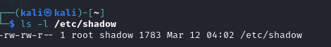

3.we examine the permissions to identify amd exploit.



4.now we modified the permissions of the shadow file using the command sudo chmod777.

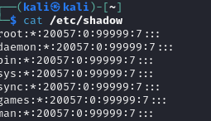

5.Now we can see the contents of the /etc/shadow file. It contains hashed passwords.

NOTE:we have successfully configured (/etc/shadow)

SECURING PERMISSIONS:

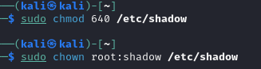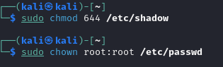

1.here we have done the following process:

*secure the password file by setting the permissions to 640 using chmod command.

*next we modify the permissions by using the command sudo chmod 644

And setting to root:root with sudo chown command.

SUMMARY OF STEPS:

| STEPS | COMMANDS | PURPOSE |
| --- | --- | --- |
| Create users | Sudo useradd username | It adds new users |
| Set passwords | Echo “username:pass | Sudo chpasswd ( helps to assign the psd) |
| Break security | Sudo chmod 777 /etc/shadow | Make shadow file |
| Exploit | Su username && cat/etc/shadow | Helps to access the password |
| Fix permissions | Sudo chmod 640 /etc/shadow | Secure the shadow file |
| Secure /etc/passwd | Sudo chmod 644/etc/passwd | Prevent unauthorized edits |
|  |  |  |
|  |  |  |